DATABASE MANAGEMENT SYSTEM MINI PROJECT REPORT
MOVIE TICKET BOOKING SYSTEM

1. Abstract

This project titled “Movie Ticket Booking System” is a web-based application designed to simplify and digitalize the movie ticket booking process. It allows users to browse movies, select theatres, choose showtimes, pick their preferred seats, and download a digital ticket. The system is developed using Python (Flask framework) for the backend and HTML, CSS for the frontend interface. It also integrates ReportLab and qrcode libraries to generate downloadable PDF tickets with embedded QR codes. The main objective of the project is to create an efficient, user-friendly, and paperless booking platform that enhances the convenience of ticket reservations. The outcome is a lightweight, responsive, and fully functional web system that demonstrates real-world booking features with smooth navigation and a modern dark-themed interface.

2. Objectives

- To design and implement a database for managing movie listings, theatres, showtimes, seat availability, and ticket bookings.
- To ensure data consistency, integrity, and accuracy throughout the booking process.
- To develop an efficient and user-friendly web interface for selecting movies, theatres, and seats seamlessly.
- To handle backend operations such as seat allocation and ticket generation securely and efficiently.
- To enable users to download digital tickets with a QR code for verification.
- To provide a smooth and interactive booking experience with a modern dark-themed design.

3. System Analysis

- Problem Definition:
In today’s fast-paced world, people often struggle with long queues, limited ticket availability, and last-minute booking hassles at movie theatres. Traditional booking methods are time-consuming and prone to human errors. Additionally, users lack a unified platform to view multiple theatres, showtimes, and seat availability in one place.The Movie Ticket Booking System addresses these challenges by providing an online platform that allows users to browse movies, select theatres and seats, and complete payments instantly. This not only saves time and effort but also ensures transparency, convenience, and an enhanced movie-going experience

- Existing System:
Time-consuming: Users must visit theatres physically to check showtimes and book tickets.
Limited accessibility: Booking can only be done during theatre working hours, not 24/7.
Prone to errors: Manual entry of ticket details often leads to mistakes or double bookings.
Lack of real-time updates: Seat availability and showtime changes are not updated instantly.
No centralized database: Data is scattered, making it difficult to track bookings and generate reports.
Inconvenient payment process: Users must make cash payments at the counter instead of secure online transactions.

- Proposed System:
Speed and Efficiency: Users can instantly view available seats, choose showtimes, and complete bookings within seconds.
Reliability: Real-time data ensures accurate seat availability and prevents double bookings.
User Convenience: Tickets can be booked anytime, anywhere through a simple web interface.
Secure Payments: Integrated payment simulation enhances user trust and ensures safe transactions.
Data Management: All booking details are stored in a centralized database, allowing easy access and report generation.
Environment Friendly: Reduces the need for physical tickets by offering downloadable digital tickets.

4. System Design

a. Entity Relationship (ER) Diagram:
Entity–Relationship (ER) Diagram
The ER diagram represents the structure of the Movie Ticket Booking System and how different entities interact with each other. It defines entities, their attributes, and the relationships among them to ensure proper database design and normalization.
Entities and Attributes:
- User
  - Attributes: User_ID, Name, Email, Phone_Number, Password
- Movie
  - Attributes: Movie_ID, Movie_Name, Genre, Duration, Language, Poster_Image
- Theatre
  - Attributes: Theatre_ID, Theatre_Name, Location
- Showtime
  - Attributes: Showtime_ID, Movie_ID, Theatre_ID, Show_Date, Show_Time, Ticket_Price
- Seat
  - Attributes: Seat_ID, Theatre_ID, Seat_Number, Status (Available/Booked)
- Booking
  - Attributes: Booking_ID, User_ID, Showtime_ID, Seat_ID, Booking_Date, Payment_Status

b. Schema Diagram:
- A User can make multiple Bookings (1-to-Many).
- A Movie can have multiple Showtimes (1-to-Many).
- A Theatre can host multiple Showtimes (1-to-Many).
- A Showtime has multiple Seats (1-to-Many).
- Each Booking is linked to one User, one Showtime, and one or more Seats

c.Data Dictionary:
Table Name | Field Name | Data Type | Size | Description
User | user_id | INT | 10 | Unique ID for each user
 | name | VARCHAR | 50 | Name of the user
 | email | VARCHAR | 100 | User’s email address
 | phone_number | VARCHAR | 15 | User’s contact number
 | password | VARCHAR | 50 | Login password for user authentication
Movie | movie_id | INT | 10 | Unique ID for each movie
 | movie_name | VARCHAR | 100 | Name of the movie
 | genre | VARCHAR | 50 | Genre of the movie (e.g., Action, Drama)
 | duration | VARCHAR | 10 | Duration of the movie
 | language | VARCHAR | 30 | Language of the movie
 | poster_image | VARCHAR | 255 | File path of the movie’s poster image
Theatre | theatre_id | INT | 10 | Unique ID for each theatre
 | theatre_name | VARCHAR | 100 | Name of the theatre
 | location | VARCHAR | 100 | Location of the theatre
Showtime | showtime_id | INT | 10 | Unique ID for each showtime
 | movie_id | INT | 10 | References movie being shown
 | theatre_id | INT | 10 | References theatre where the movie is played
 | show_date | DATE | — | Date of the show
 | show_time | TIME | — | Time of the show
 | ticket_price | DECIMAL | 10,2 | Price of one ticket
Seat | seat_id | INT | 10 | Unique ID for each seat
 | theatre_id | INT | 10 | References theatre the seat belongs to
 | seat_number | VARCHAR | 10 | Seat label (e.g., A1, B5)
 | status | VARCHAR | 10 | Indicates whether seat is ‘Available’ or ‘Booked’
Booking | booking_id | INT | 10 | Unique ID for each booking
 | user_id | INT | 10 | References the user who made the booking
 | showtime_id | INT | 10 | References the booked showtime
 | seat_id | INT | 10 | References the booked seat
 | booking_date | DATETIME | — | Date and time when the booking was made
 | payment_status | VARCHAR | 20 | Indicates if payment is ‘Paid’ or ‘Pending’

5. Implementation

a. Software & Hardware Requirements:
- Software:
• Frontend: HTML, CSS (Modern Dark Theme)
• Backend: Python (Flask Framework)
• Database: MySQL
• Tools Used: VS Code, SQLyog / phpMyAdmin
• Operating System: Windows 10 or above
• Browser: Google Chrome / Microsoft Edge

- Hardware:
• Processor: Minimum 1.6 GHz or higher
• RAM: Minimum 4 GB
• Storage: At least 500 MB free space
• Display: 1366×768 resolution or higher

b. SQL Queries Used:
- Table creation (DDL)
CREATE TABLE movies (
movie_id INT PRIMARY KEY AUTO_INCREMENT,
title VARCHAR(100),
genre VARCHAR(50),
duration INT
);
CREATE TABLE theatres (
theatre_id INT PRIMARY KEY AUTO_INCREMENT,
name VARCHAR(100),
location VARCHAR(100)
);
CREATE TABLE bookings (
booking_id INT PRIMARY KEY AUTO_INCREMENT,
movie_id INT,
theatre_id INT,
user_name VARCHAR(100),
seats INT,
FOREIGN KEY (movie_id) REFERENCES movies(movie_id),
FOREIGN KEY (theatre_id) REFERENCES theatres(theatre_id)
);

- Data insertion (DML)
INSERT INTO movies (title, genre, duration)
VALUES ('Leo', 'Action', 160);
INSERT INTO theatres (name, location)
VALUES ('PVR Sathyam', 'Chennai');

- Retrieval (SELECT with conditions)
SELECT title, genre FROM movies WHERE genre = 'Action';
- Joins, views, indexes, and stored procedures
SELECT b.user_name, m.title, t.name
FROM bookings b
JOIN movies m ON b.movie_id = m.movie_id
JOIN theatres t ON b.theatre_id = t.theatre_id;
CREATE VIEW booking_summary AS
SELECT user_name, title, name FROM bookings
JOIN movies USING(movie_id)
JOIN theatres USING(theatre_id);
CREATE INDEX idx_movie_title ON movies(title);
DELIMITER //
CREATE PROCEDURE GetBookings()
BEGIN
SELECT * FROM bookings;
END //
DELIMITER ;

6. Sample Outputs

Home Page:

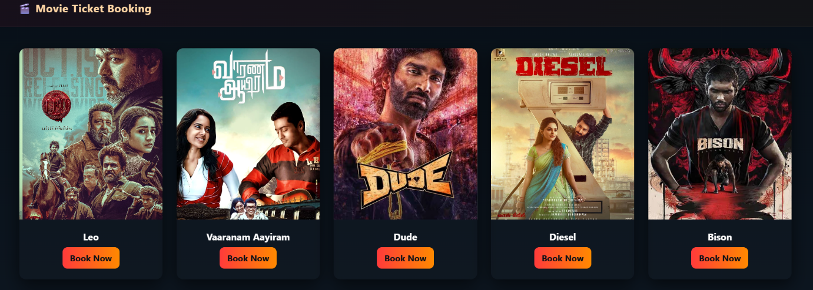

Theatres List Page:

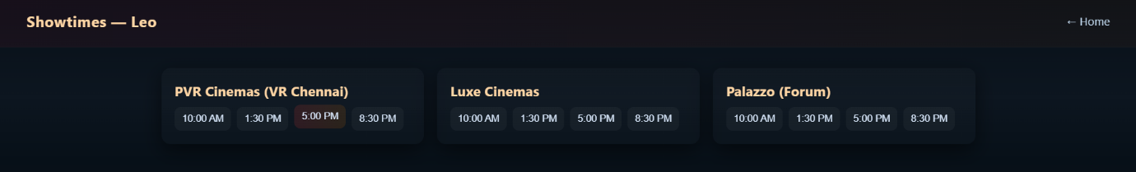

Seats Selection Page:

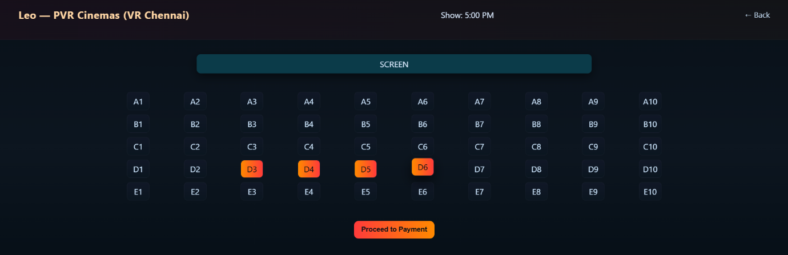

Payment Page:

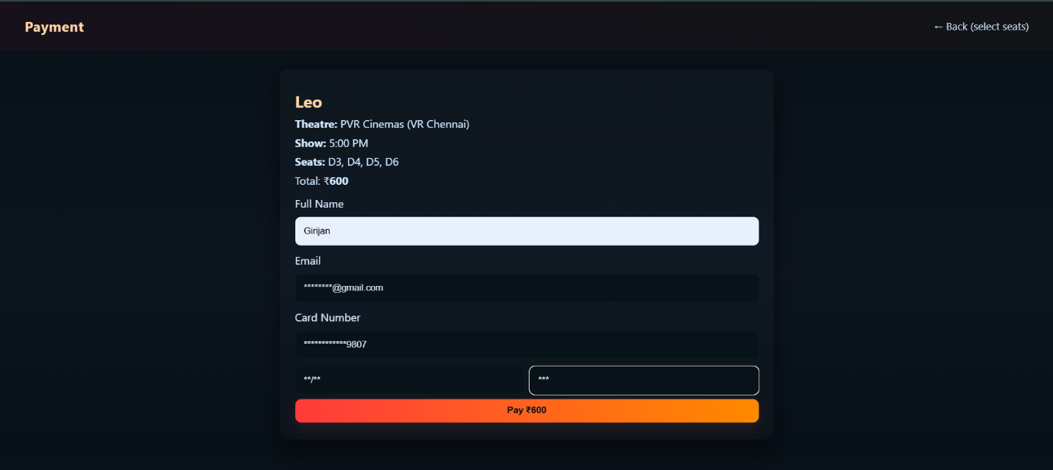

Booking Confirmation Page:

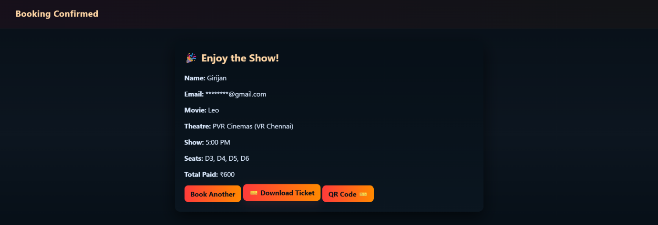

Downloaded Movie Ticket with QR Code:

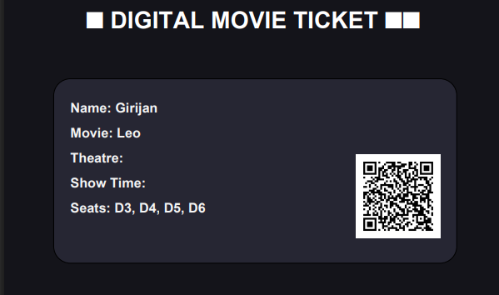

7. Results and Discussion

This Movie Ticket Booking System successfully meets its objectives by providing a smooth and efficient platform for selecting movies, choosing theatres, booking seats, and confirming tickets. The database ensures data accuracy, consistency, and integrity, while the Flask-based interface offers a fast and user-friendly experience.
The system eliminates manual errors, reduces waiting time, and improves overall reliability.
Possible improvements include integrating online payment gateways, user authentication, and real-time seat availability tracking to enhance convenience and scalability.

8. Conclusion

This Movie Ticket Booking System successfully automates the entire process of movie ticket reservation — from selecting movies and theatres to confirming bookings. It achieves faster processing, improved data handling, and an intuitive user experience.
In the future, the system can be extended by integrating secure online payments, QR-based e-tickets, user accounts with booking history, and AI-based movie recommendations to make it more robust and scalable.

9. References

• “Database System Concepts” by Abraham Silberschatz, Henry F. Korth, and S. Sudarshan
• “Fundamentals of Database Systems” by Ramez Elmasri and Shamkant Navathe
• https://www.mysql.com
• https://flask.palletsprojects.com
• https://www.w3schools.com

